**“Robby” Capstone Project 2022-23**

*Dr. George Violettas*

**Abstract**

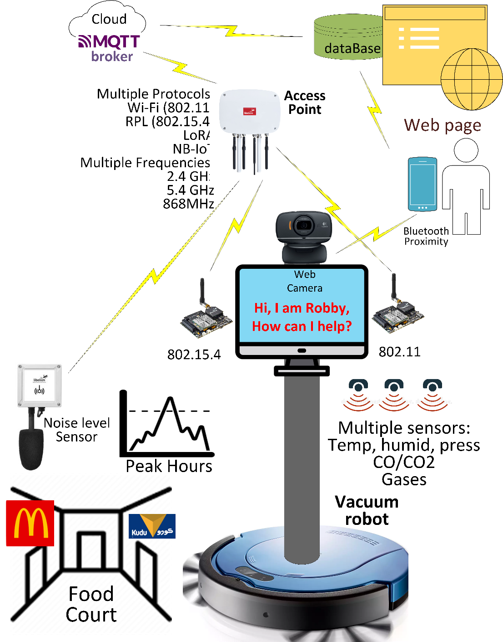Within the project, multiple environmental and ambient readings are collected from a network of multiple sensors, and dedicated equipment, communicating via multiple protocols, frequencies, and standards. The readings combined with data gathered from the interaction with the user via voice, picture, and video collected by the autonomous, intelligent machine wandering around based on an automatic vacuum, will be sent to a cloud infrastructure for further processing and decision making. Data will be depicted in a dedicated, interactive webpage, and also provided as a feed to user’s mobile application(s). Power user(s) can also interact with “Robby” via Bluetooth proximity identification. The projects aims to be continuous, and beyond the end of the current capstone project.

**Team Members**

Nawaf Alzahem

Fahad Aldulaigan

Mohammad Abuhaimed

Khalid Abu Alsaud

Khalid Hali